Aplicación 1.1: Consumo privado en Estados Unidos

**Lectura de datos**

library(fpp3) # Este package contiene varios elementos

## ── Attaching packages ────────────────────────────────────────────────────────────────────────────────────────────────────────────── fpp3 0.3 ──

## ✓ tibble 3.0.3 ✓ tsibble 0.9.2  
## ✓ dplyr 1.0.2 ✓ tsibbledata 0.2.0  
## ✓ tidyr 1.1.2 ✓ feasts 0.1.5  
## ✓ lubridate 1.7.9 ✓ fable 0.2.1  
## ✓ ggplot2 3.3.2

## ── Conflicts ───────────────────────────────────────────────────────────────────────────────────────────────────────────────── fpp3_conflicts ──  
## x lubridate::date() masks base::date()  
## x dplyr::filter() masks stats::filter()  
## x tsibble::interval() masks lubridate::interval()  
## x dplyr::lag() masks stats::lag()

CONS_USA <- readr::read_csv("CONS_USA.csv")

## Parsed with column specification:  
## cols(  
## obs = col_double(),  
## C = col_double(),  
## Y = col_double()  
## )

**“Tidyversización” de los datos**

CY_USA <- CONS_USA[,2:3] %>%  
 mutate(Year = 1959:2015) %>%  
 as_tsibble(index = Year)

**Gráfico**

CY_USA %>% autoplot(vars(C,Y)) +  
 ggtitle("Consumo privado y renta disponible en Estados Unidos") +  
 ylab("$ million") + xlab("Year")

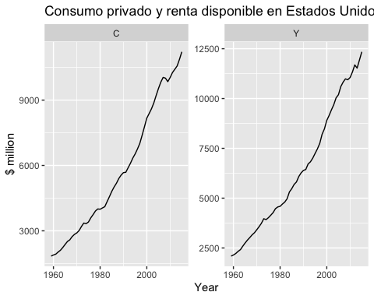

**Diagrama de puntos + regresión**

CY_USA %>%  
 ggplot(aes(x=Y, y=C)) +  
 ylab("Consumo") +  
 xlab("Renta") +  
 geom_point() +  
 geom_smooth(method="lm", se=FALSE)

## `geom_smooth()` using formula 'y ~ x'

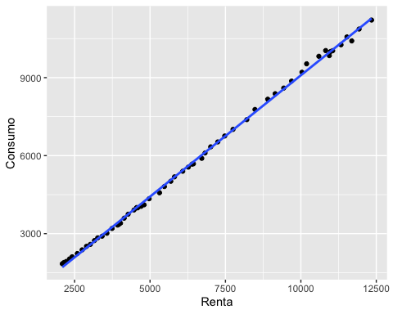

**Modelo de regresión lineal**

CY_USA %>%  
 model(tslm = TSLM(C ~ Y)) %>%   
 report()

## Series: C   
## Model: TSLM   
##   
## Residuals:  
## Min 1Q Median 3Q Max   
## -252.922 -52.961 -6.074 55.160 263.545   
##   
## Coefficients:  
## Estimate Std. Error t value Pr(>|t|)   
## (Intercept) -2.455e+02 2.828e+01 -8.681 6.87e-12 ***  
## Y 9.336e-01 3.967e-03 235.338 < 2e-16 ***  
## ---  
## Signif. codes: 0 '***' 0.001 '**' 0.01 '*' 0.05 '.' 0.1 ' ' 1  
##   
## Residual standard error: 92.95 on 55 degrees of freedom  
## Multiple R-squared: 0.999, Adjusted R-squared: 0.999  
## F-statistic: 5.538e+04 on 1 and 55 DF, p-value: < 2.22e-16